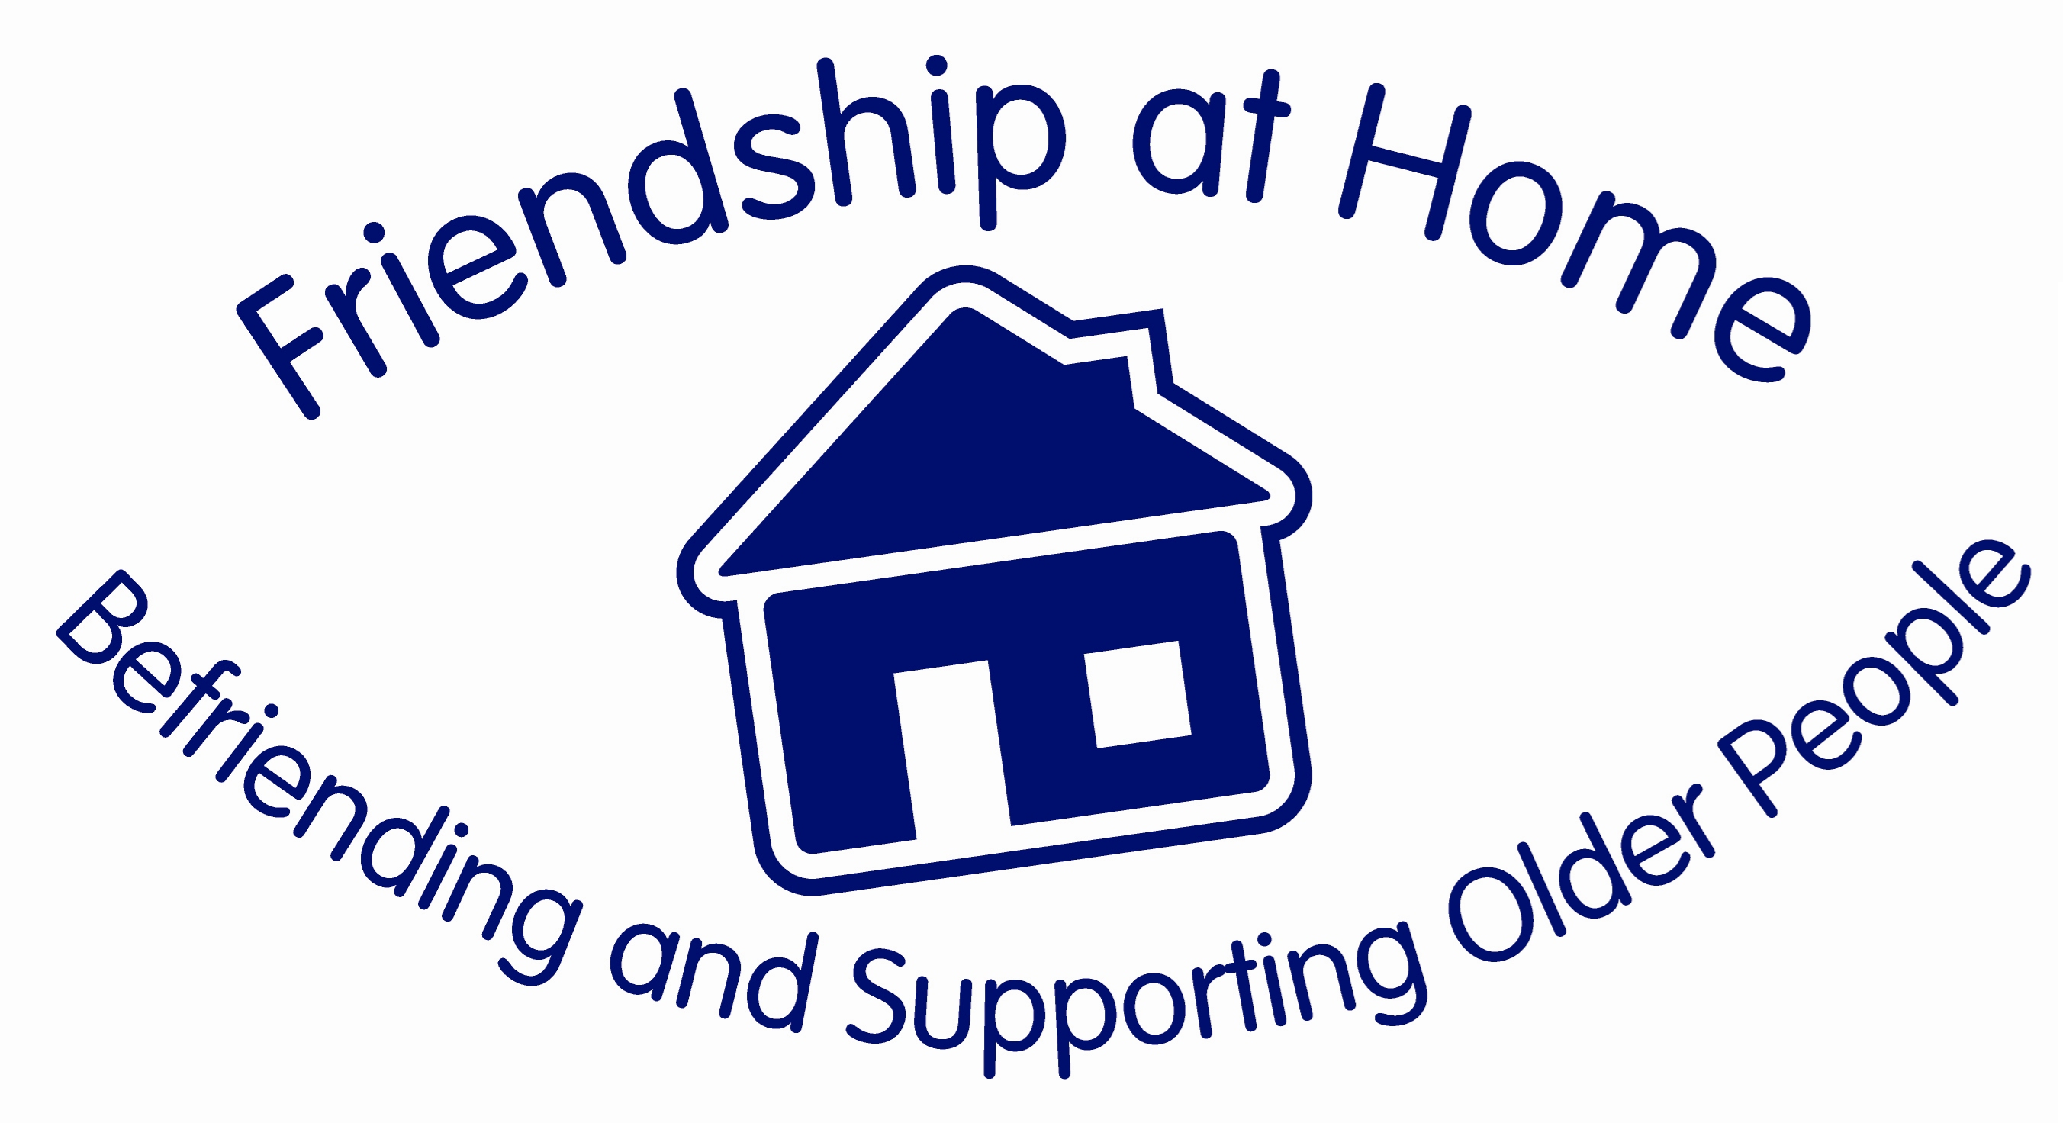

Volunteer Application Form

Name: …………………………………………………………………………………………………………………………………………….………
Address: ……………………………………………………………………………………………………………………………………..…………
…………………………………………………………………………………………………………………………………………………………………..
Postcode: …………………………………………………………. D.O.B ………………………………………………………
Home Phone: ………………………………………..…… Mobile: ……………………………………………………………………
Email: ……………………………………………………………………………………………………………………..……………………………….
Please provide an emergency contact name and telephone number.

Name: ……………………………………………………………………………………………….

Phone: ………………………………………………… Mobile: ………………………………………………………..…………

What type of volunteering would you like to do?
(Please tick whatever types of volunteering you are able to offer)

Befriending |  |  | Fund Raising
Social Activities |  |  | Assisted Shopping
Driving |  |  | Gardening
Domestic (cleaning, ironing etc.) |  |  | Dog Walking

How did you hear about us?
Skills:

Hobbies and interests:

Please indicate any voluntary or other experience that you feel may be relevant to the role you have applied for (e.g. community work):

Availability

One off requests |  |  | Regular help

 | Mon | Tues | Wed | Thurs | Fri | Sat | Sun
am
pm
eve

Are there times you are not available? ……………………………………………………………………………………

How much time are you able to give per week?

30 minutes 1-2 hours 3-4 hours 4+ hours i

Do you have a geographic preference as to where you do your volunteer work?
Yes No If yes, please state …………………………………………………………
Do you have access to a car you can use for volunteer work?
Yes No

If you are interested in befriending:
In order for us to match you with the right person, please answer the following questions:
Would you be willing to visit a person who has pets? Yes Maybe No
Would you be willing to visit a person who smokes? Yes Maybe No
Disabilities or health problems do not preclude you from volunteering, and all information will be treated as confidential.
(Please tick where appropriate)

Are you generally in good health? Yes No

Do you suffer from a recognised disability as
outlined in the Disability Discrimination Act (DDA)? Yes No

If yes, please indicate the nature of the disability.

We understand that people have different needs and requirements, please share with us anything about yourself that will enable us to offer you appropriate and sufficient support.
Do you have any concerns about being involved with a particular group of people, which you would like to discuss further?

Yes No
All applicants who are being considered for a volunteer role will be subject to a Disclosure and Barring Service Check (DBS).

Have you ever been convicted of a criminal offence? Yes No

If yes, please state the nature of the conviction and date:

We do not discriminate against people with criminal convictions unless these are relevant to the post. However please note you may be questioned about any convictions before an offer is made.
Do you agree to your details being included on our Volunteer Database?

Yes No
Declaration:

I confirm that the statements given in this application are true and accurate to the best of my knowledge.
Signed:
Date:

Please return to:

Friendship at Home
C/o Parish Office
St Aidan’s Community Church
Grimsby Road
Cleethorpes
DN35 7RQ

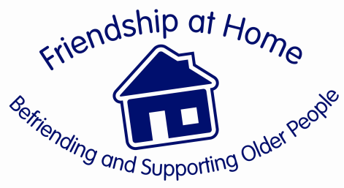

Volunteer Application Form References
Name of Applicant:
Because you will be working with vulnerable people/sensitive information we will need to check that you are honest and trustworthy. To help us do this we are asking you to provide the name and address of two people who would be able to give us a reference on your behalf.

Suitable people to ask for a reference include an employer or previous employer, a professional person you have regular contact with and a personal friend.

Please check with them before giving their names as referees.

If you have any problems thinking of suitable people please get in touch with us, as we will be happy to help if we can.
1st Referee

Name:
Address:

Postcode: Phone number:
2nd Referee

Name:
Address:

Postcode: Phone number:
Please return this form to: Friendship at Home
C/o Parish Office
St Aidan’s Community Church,
Grimsby Road,
Cleethorpes
DN35 7RQ

